Project Report

**ProjectTitle:**

**HematoVision: Advanced Blood Cell ClassificationUsingTransferLearning**

**Team Id: LTVIP2025TMID34188**

**Team members :**

**Team Size :** 4

**• Team Leader :** VASA GEETHIKA

**•Team member :** UVLLI CHAITANYA LAKSHMI

**•Team member :** Usirika Gnana Lakshmi Snigdha

**•Team member :** V THARUNI

# INTRODUCTION

## Project Overview

HematoVision is an AI-driven project that utilizes deep learning and transfer learning to classify different types of human blood cells. The system is built upon a pre-trained MobileNetV2 architecture and aims to assist healthcare professionals by providing fast, accurate, and automated analysis of blood smear images.

## Purpose

The primary purpose of HematoVision is to reduce the manual workload on pathologists and improve diagnostic accuracy. It serves as a tool for diagnostics, telemedicine, and medical education by providing a scalable and efficient solution for blood cell classification.

# IDEATION PHASE

## Problem Statement

Manual classification of blood cells is time-consuming, error-prone, and requires expert intervention. There is a need for an automated solution that can accurately classify blood cells with minimal human effort.

## Empathy Map Canvas

**Users:**

Pathologists, Lab Technicians, Medical Students

## Pain Points:

Manual classification is time-consuming and prone to error Inconsistent diagnostic accuracy

Limited access to expert pathologists in rural areas

## Needs:

Fast and accurate blood cell identification

An easy-to-use tool integrated into existing workflows Interactive support for medical learning and practice

## Gains:

Improved diagnostic speed and reliability Reduced workload and decision fatigue

Better access to diagnostic tools in remote areas Enhanced medical education through hands-on training

## Brainstorming

* + - Use of CNNs and transfer learning for efficiency.
    - Deployment via web app using Flask.
    - Scenarios: diagnostics, telemedicine, and education.
    - Expandable model architecture.

# REQUIREMENT ANALYSIS

## Customer Journey Map

1. Uploads blood image via UI.
2. Image processed by Flask-integrated model.
3. Model predicts and shows cell type.
4. User receives instant result.

## Solution Requirements

* + - Labeled blood cell image dataset.
    - Pre-trained CNN model (MobileNetV2).
    - Web framework (Flask).
    - Tools: Anaconda, Python, HTML/CSS.

## Data Flow Diagram

User Input → Flask UI → Model Prediction → Result Output

## Technology Stack

* + - Python, TensorFlow, Flask
    - HTML, CSS, JavaScript
    - Anaconda, Jupyter Notebook

# PROJECT DESIGN

## Problem-Solution Fit

The problem of time-intensive blood cell classification is effectively addressed using transfer learning with a pre-trained MobileNetV2, reducing training costs and improving accuracy**.**

## Proposed Solution

Develop an AI model using transfer learning and deploy it via a Flask web app for user- friendly interaction and prediction**.**

## Solution Architecture

* + - Data preprocessing & augmentation
    - Train/test split
    - Model building using MobileNetV2
    - Model evaluation and saving
    - Flask-based web deployment
    - Architecture:

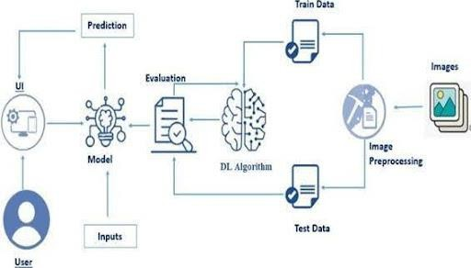

# PROJECT PLANNING & SCHEDULING

## Project Planning

* + - Week 1: Data collection and preprocessing
    - Week 2: Model training and testing
    - Week 3: Flask web integration
    - Week 4: UI building, testing, and documentation

# FUNCTIONAL AND PERFORMANCE TESTING

## Performance Testing

The model is evaluated using classification metrics. It demonstrates high accuracy across all four blood cell classes they are Eosinophil, Lymphocyte, Monocyte, Neutrophil. Predictions are fast, allowing real-time use in clinical setups.

# RESULTS

* 1. **Output Screenshots**

**PROJECT STRUCTURE AND VS CODE**

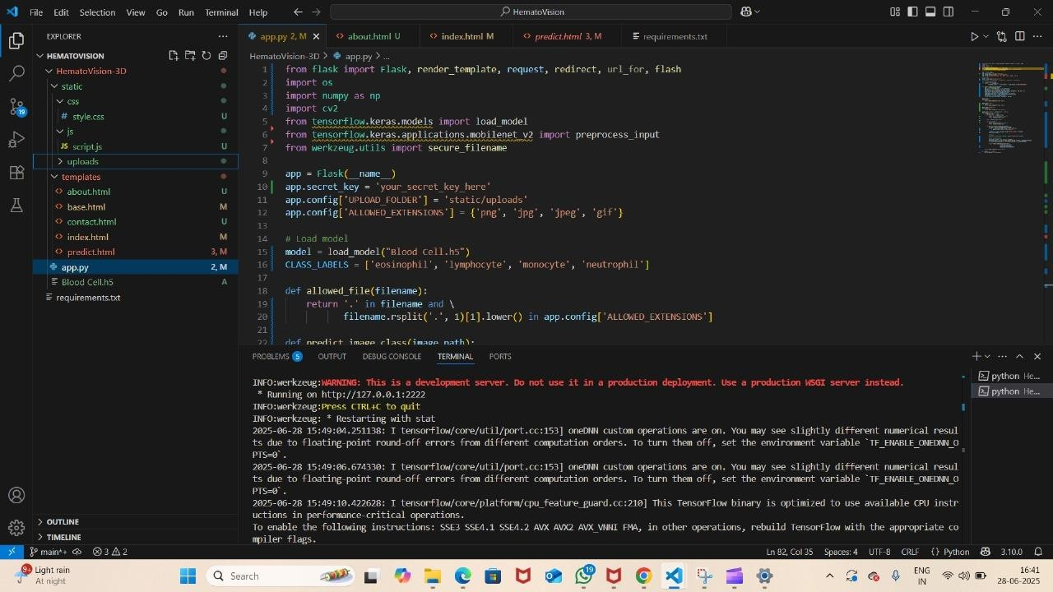

**HEMATOVISION WEB PAGE:**

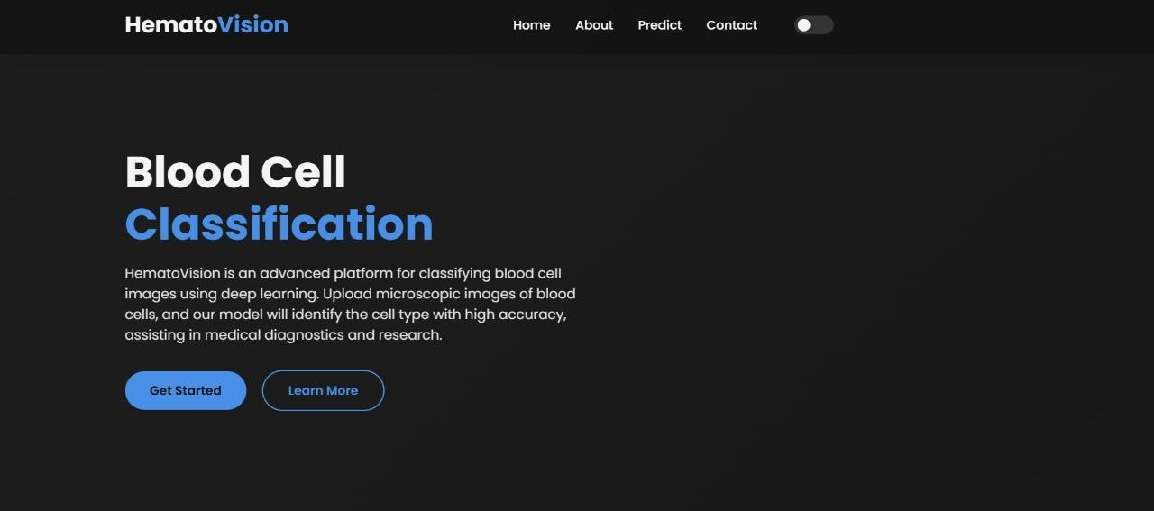

**ANALYSIS RESULT:**

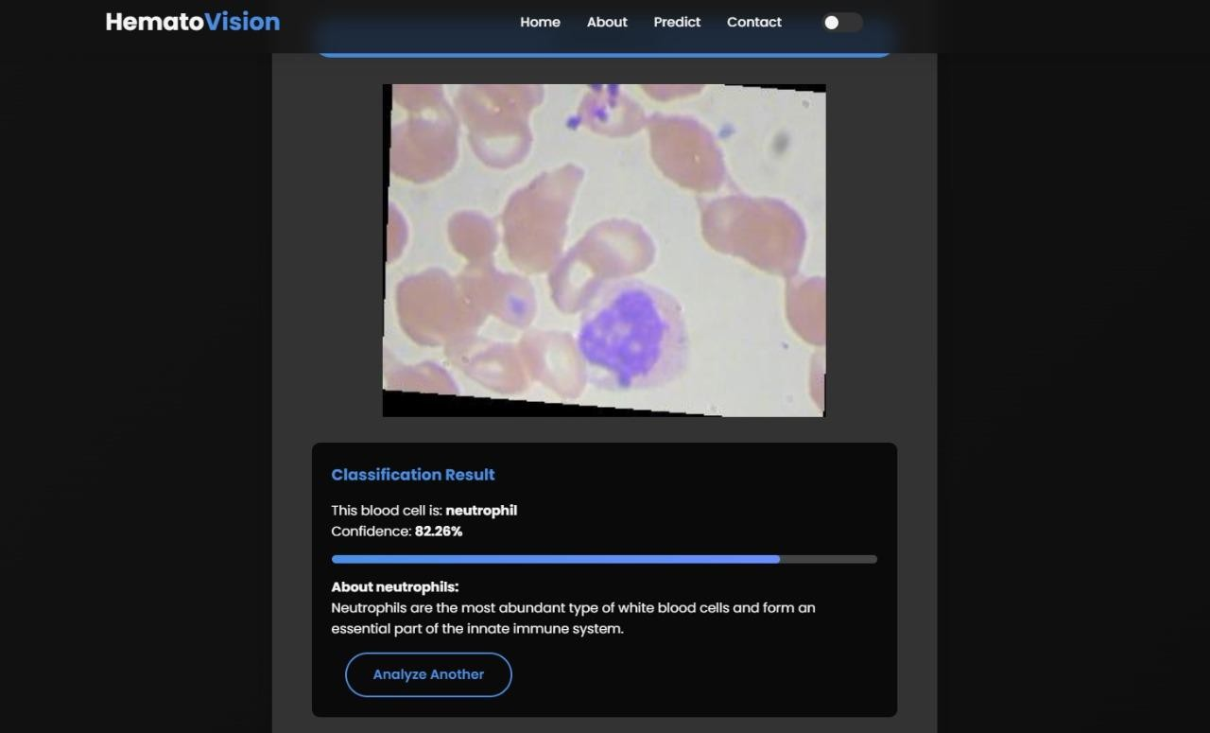

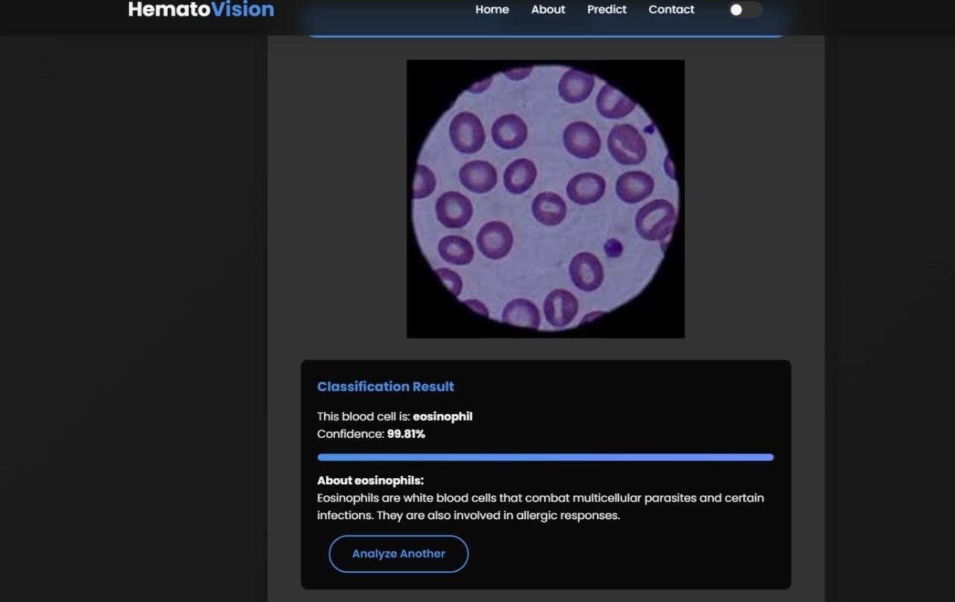

1. **ADVANTAGES & DISADVANTAGES**

## Advantages

* High classification accuracy
* Fast processing and prediction
* Supports remote diagnostics
* Reduces workload of pathologists
* Acts as a training tool for students

## Disadvantages

* Limited to four cell types
* Sensitive to image quality
* Lacks interpretability of decision-making
* Requires initial setup and hardware for training

# CONCLUSION

The HematoVision project successfully showcases how artificial intelligence, specifically deep learning with transfer learning, can significantly enhance the accuracy and efficiency of medical diagnostics. By utilizing a pre-trained MobileNetV2 model and a robust dataset of blood cell images, the system achieves commendable performance in classifying four primary types of blood cells: neutrophils, lymphocytes, monocytes, and eosinophils.

Through the integration of this model into a user-friendly Flask-based web application, HematoVision bridges the gap between complex AI technology and practical medical use. This makes it a valuable tool not only for pathologists seeking faster and more accurate diagnostics but also for educational institutions looking to provide interactive, hands-on training in hematology.

The project emphasizes the value of transfer learning in reducing training time and computational overhead while still maintaining high accuracy. It also underlines the importance of clean, labeled data in building reliable AI systems for healthcare. Although currently limited to a specific set of cell types, the architecture and design allow for future expansion and adaptation.

In conclusion, HematoVision represents a significant step toward democratizing diagnostic tools, making high-quality medical image analysis more accessible, scalable, and efficient. It stands as a practical example of how AI can be harnessed to support and enhance human expertise in the healthcare sector.

# FUTURE SCOPE

* Addition of more blood cell types
* Implementation of explainable AI methods
* Mobile app development
* Direct microscope integration for live predictions
* Cloud-based access for scalable use across hospitals

# APPENDIX

### Dataset for HematoVision: Advanced Blood Cell Classification Using Transfer Learning

**Link:** [**https://www.kaggle.com/datasets/paultimothymooney/blood-cells/data**](https://www.kaggle.com/datasets/paultimothymooney/blood-cells/data)

**Demo video link:** <https://drive.google.com/file/d/12bj0QX_fNYvvVSJ12AXgKRlseQI52waH/view?usp=drive_link>